# 0304-342-01: Problem Solving with Computers, Spring 2012 (2011-3)

**Exam #2 – VBA**  
Individual Work, Closed Book & Files, 50 minutes

**Instructions:** *Read carefully!*

* *Complete all of the following problems in a single Excel workbook, one problem per worksheet with all of the VBA code in a single module. Download and complete your work in the Excel template provided on myCourses. There is also an electronic copy of this exam sheet on myCourses for your convenience.*
* *You must complete the exam using the lab PCs – do not use your own computer.*
* *You may use your single-sided 8½”x11” syntax notes sheet during the exam. You may also use the built-in Help system in Excel / VBA, but no other files or webpages or other written or electronic aids.*
* *Save your work often during the exam period!*
* *When you are done, upload your Excel workbook to the* ***Exam #2 (VBA)*** *Dropbox on myCourses. The filename must include your name, PSWC-Section#, and Exam#2. The Dropbox will remain open for 5 minutes beyond the end of the class period for you to save your file and complete the Dropbox submission. Failure to complete the submission by the Dropbox deadline will result in a significant score penalty.*
* *Read, sign, and date the honor pledge at the bottom of the reverse side of this exam sheet.*
* *Be sure to put your name on this exam paper, answer the indicated questions in the provided spaces, and staple your syntax notes sheet to the back of the sheet. Turn the exam sheet with your notes sheet in to the instructor before you leave. You are not required to edit the electronic copy of this exam nor upload it to the Dropbox.*
* *VERIFY that your submission to the Dropbox was successful before you leave!*

**Problem #1:** *(10 pts)*

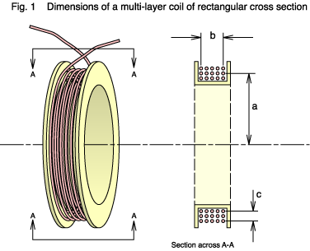Solenoid valves are actuated by an electromagnetic force generated by electric current in a coil of wire. The force depends on the number of windings and the current, which in turn depends on the resistance of the coil (for a constant supply voltage). A set of 30 coils produced by a new coil-winding machine have been checked for resistance. The intended resistance and the tolerance are given on *Sheet1* in the Excel workbook template, along with the results of the testing.

Write a VBA Sub procedure which reads the measured voltages from the spreadsheet into an array and decides whether each coil passes (resistance within the tolerance around the design point) the test, fails “Low-R” (resistance below the tolerance limit), or fails “High-R” (resistance above the tolerance limit).

Your VBA Sub procedure should write “Pass”, “FAIL LOW-R”, or “FAIL HIGH-R”, as appropriate, in the column next to the resistance measurements. It should also tabulate the number of occurrences of each outcome and write the totals in to the table to the right of the data.

**Question:** How many coils fail “Low-R” and how many fail “High-R”?

**Answer:**

**Problem #2:** *(10 pts)*

According to the famous mathematician Euler, the following infinite series converges to the value shown. Write a VBA Sub procedure which evaluates this sum to an accuracy of 0.001. Write the sum and the number of terms required in the indicated cells on *Sheet2* in the Excel workbook template provided.

**Question:** How many terms are required to evaluate the sum to an accuracy of 0.001?

**Answer:**

**Honor Pledge:**

*Since the multiple sections of this course do not take the exam at a common time, please sign and date the honor pledge below and check the appropriate box below. The university and the Kate Gleason College of Engineering take academic honesty very seriously.*

I will not discuss the contents of this exam with anyone until after all students have completed this exam. I will not share any written or electronic materials related to this exam with anyone.

**Sign & Date:**

My syntax notes sheet is attached: 🞏 I did not prepare or use a syntax notes sheet. 🞏